Why do we need to implement a program that analyze a file description for a compiler

On 20121101
We want to write a program that do Data Base management. We want to set the compiler as we want with the syntax that we want. For ease of use and, modification, we describe the syntax, grammar, constraints in a single file.

On 20121206
Then this file stored in memory is reduced as a regular expression. This expression will check the final query to see it is regular.
Hence to do that, this file will be parsed and analyzed in order to compare it with the user's syntax. If the user's syntax is not correct then there will be error of compilation. Nothin' much...

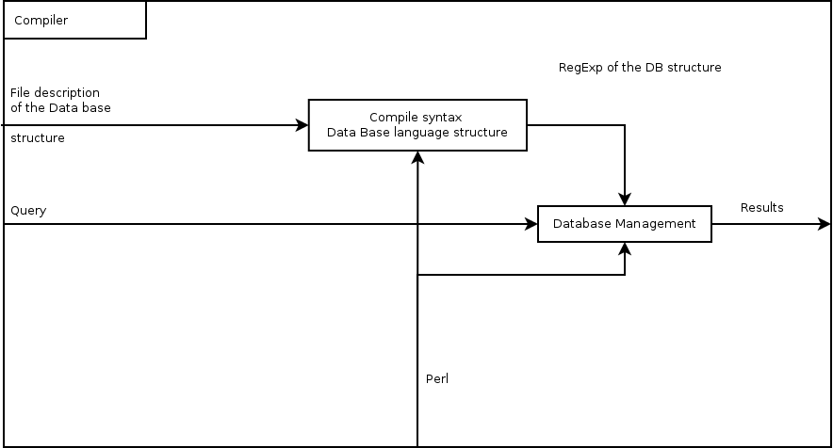Illustration 1: Structure of the compiler
This drawing describe the mecanism of the compiler.

